Robert H. McNeill
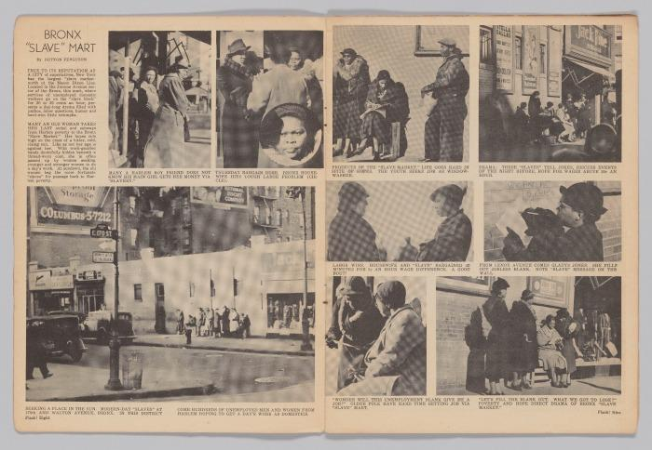
Spread from “The Bronx Slave Market.” Flash Weekly Newspicture Magazine. February 14, 1938. Ink on paper, 11 7/8 x 8 7/8" (30.2 x 22.5 cm) overall. Collection of the Smithsonian National Museum of African American History and Culture. Gift from Charles A. Harris and Beatrice Harris in memory of Charles “Teenie” Harris. Photo courtesy the Smithsonian National Museum of African American History and Culture
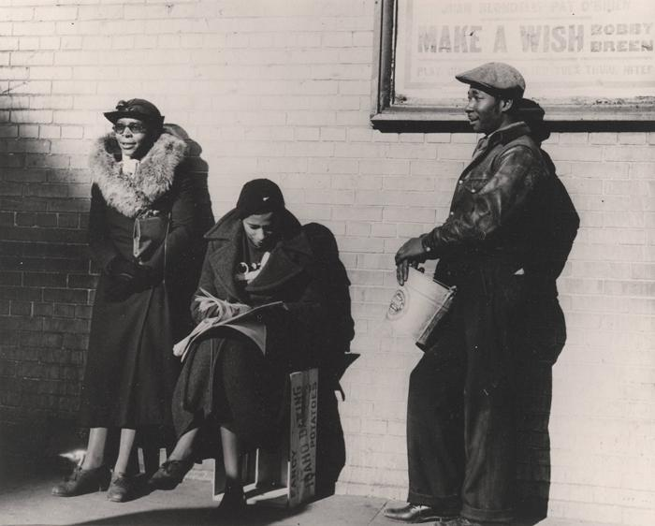
Robert H. McNeill. Make a wish. 1937. Gelatin silver print, 6 3/4 × 8 11/16" (17.1 × 22 cm). The Museum of Modern Art, New York. Acquired through the generosity of The Friends of Education of The Museum of Modern Art and Committee on Photography Fund. © 2020 Heirs of Robert H. McNeill
At the age of twenty, Robert McNeill moved to New York to study photography. There, he received a tip that Fortune magazine was looking for photographs of domestic workers and he began a series of images anchored by an intersection in the Bronx where Black men and women would gather to negotiate day jobs with potential white employers. Though Fortune ultimately rejected the pictures, they were picked up by Flash!, a Black-published magazine based out of Washington, D.C. Thirteen of McNeill’s images appeared in the February 14, 1938 issue, including this one. One woman studies a newspaper, while the other two figures look hopefully toward the street, unintentionally embodying the message from the movie poster above the man’s head: “MAKE A WISH.”
The setting for this series was the intersection of 170th Street between Jerome and Walton Avenues, known as the Bronx Slave Market. McNeill later recalled, “The idea that this woman had come up from the South, maybe was staying with relatives in New York and needed to help pay the rent, and ended up doing what she had known in the South. Or the expression on the white woman’s face, after she offers to pay 15 cents [an hour] and [the potential employee] says, ‘Uh-uh, 20 cents is my price.’ I guess the pictures were too strong for Fortune, though, because they were never used.”

Takuma Nakahira
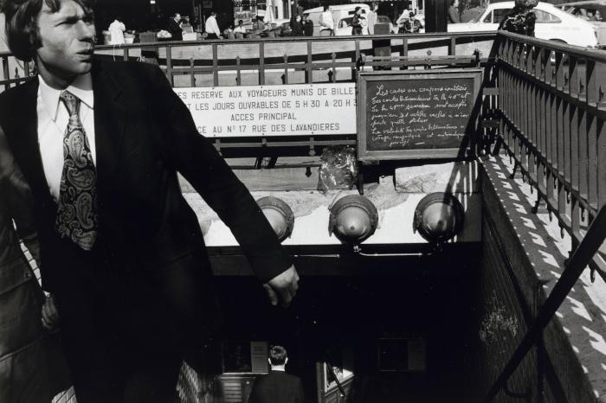
Takuma Nakahira. C-177 from the series Circulation: Date, Place, Events. 1971. Gelatin silver print, printed 2013, 12 5/8 × 18 7/8" (32.1 × 48 cm). The Museum of Modern Art, New York. David H. McAlpin Fund. © 2020 Takuma Nakahira. Courtesy Yossi Milo Gallery
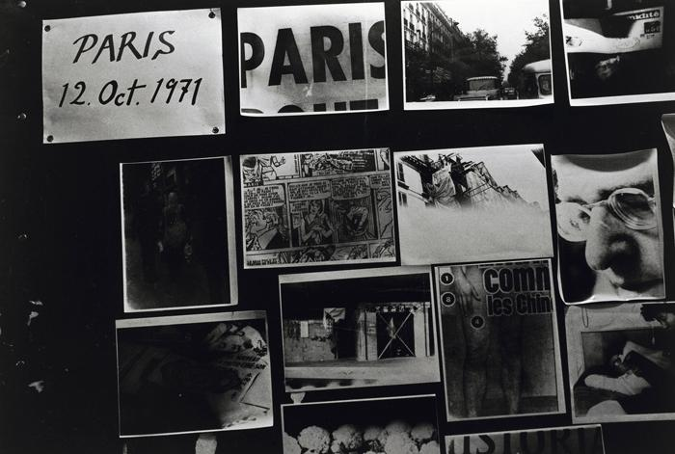
Takuma Nakahira. C-084 from the series Circulation: Date, Place, Events. 1971. Gelatin silver print, printed 2013, 12 5/8 × 18 7/8" (32.1 × 48 cm). The Museum of Modern Art, New York. David H. McAlpin Fund. © 2020 Takuma Nakahira. Courtesy Yossi Milo Gallery
Invited to participate in the Seventh Paris Biennale, Takuma Nakahira arrived in the city several days late. Instead of displaying photographs of Japan, as the exhibition’s curators had requested, Nakahira contributed a group of photographs accumulated over the course of seven days in Paris. Describing his process, the artist states, “I set myself to photograph, develop, and exhibit nothing but the Paris that I was living and experiencing.”
After exposing multiple rolls of film over the course of a day, he would immediately develop them, make prints of the images, and tack them up for display that same evening, often still wet. The next day he would begin again so that the resulting series, Circulation: Date, Place, Events, became the product of a daily routine. For Nakahira, these photographs were the “mere remnants” of his process, which consisted of his own circulation around the city as well as the circulation of images, from darkroom to display.

Richard Misrach
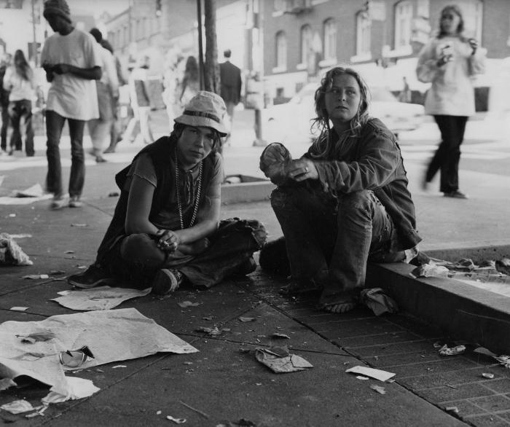
Richard Misrach. Mona and friend. 1972–74. Gelatin silver print, 9 5/8 × 11 7/16" (24.4 × 29 cm). The Museum of Modern Art, New York. Acquired through the generosity of Robert Harteveldt. © 2020 Richard Misrach
In his 1974 photo book Telegraph 3 A.M., Misrach recounts the project’s origins in a prophetic dream: “I took the dream as a mandate to photograph the faces I had seen, which I recognized as the street people of Telegraph Avenue.” Misrach followed this call, capturing the often homeless inhabitants of the major thoroughfare he traversed daily on his way to work at the University of California campus in Berkeley.
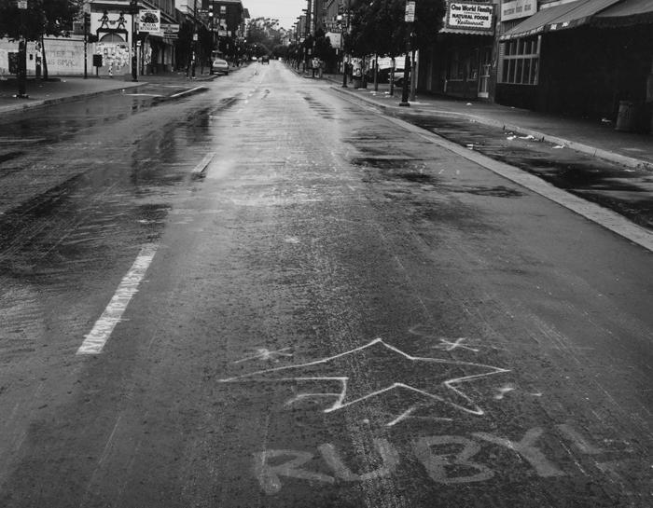
Richard Misrach. Untitled from the series Telegraph 3 A.M. 1972–74. Gelatin silver print, 9 1/4 × 11 5/8" (23.5 × 29.5 cm). The Museum of Modern Art, New York. Acquired through the generosity of Robert Harteveldt. © 2020 Richard Misrach
Here, the name Ruby emblazoned on the street calls forward the many faces and lives he encountered while creating this series. Depicting the struggles of displaced young people, Telegraph 3 A.M. exposes the suffering and disillusionment that followed the romantic ideals of the 1960s counterculture movement.
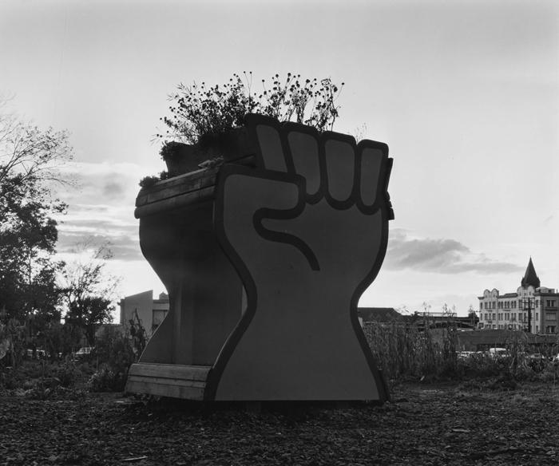
Richard Misrach. Untitled from the series Telegraph 3 A.M. 1972–74. Gelatin silver print, 9 7/8 × 11 3/4" (23.5 × 29.5 cm). The Museum of Modern Art, New York. Acquired through the generosity of Robert Harteveldt. © 2020 Richard Misrach
A block of land just off Telegraph Avenue was purchased by UC Berkeley in 1967. When it remained undeveloped for a period of time, community members seized the land, transforming it into People’s Park. It was a site of gathering for members of the Black Panther Party and the free speech movement, as well as an encampment for many homeless youth. In this photograph, flowers and plants sprout from the raised fist. This depiction of growth and resilience, paired with a symbol of solidarity and strength for several human rights movements, illustrates the park’s role as a sanctuary for many people. Today, People’s Park faces significant change as UC Berkeley constructs student housing on its grounds.

Nicholas Nixon
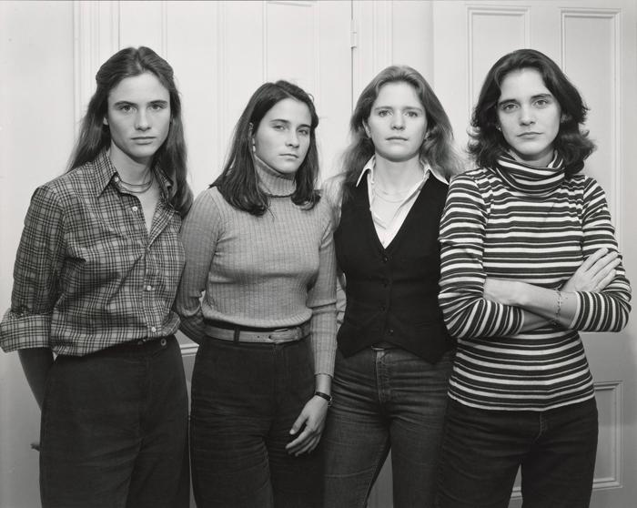
Nicholas Nixon. The Brown Sisters, Cambridge, Massachusetts. 1977. Gelatin silver print, 7 11/16 × 9 11/16" (19.6 × 24.5 cm). The Museum of Modern Art, New York. John Parkinson III Fund. © 2020 Nicholas Nixon
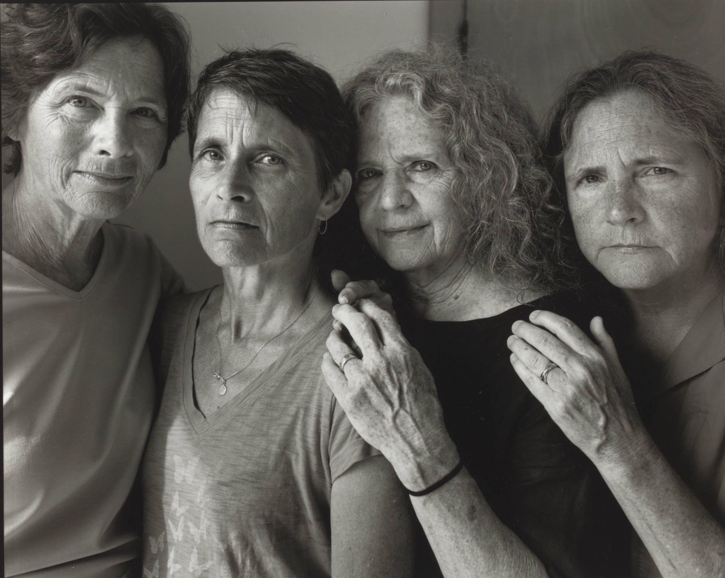
Nicholas Nixon. The Brown Sisters, Truro, Massachusetts. 2016. Gelatin silver print, 16 × 20" (40.6 × 50.8 cm). The Museum of Modern Art, New York. John Szarkowski Fund. © 2026 Nicholas Nixon
In 1975, Nicholas Nixon began photographing his wife, Bebe, and her three sisters, Mimi, Laurie, and Heather, for what has become a series called The Brown Sisters. Nixon always uses an 8 x 10 inch view camera on a tripod to take a handful of exposures, each one captured on a black-and-white-film negative. From these exposures he and his subjects confer to select the final portrait. Although the sisters always appear in the same order year after year, the passage of time marks these intimate portraits of the photographer’s family.

Leslie Hewitt
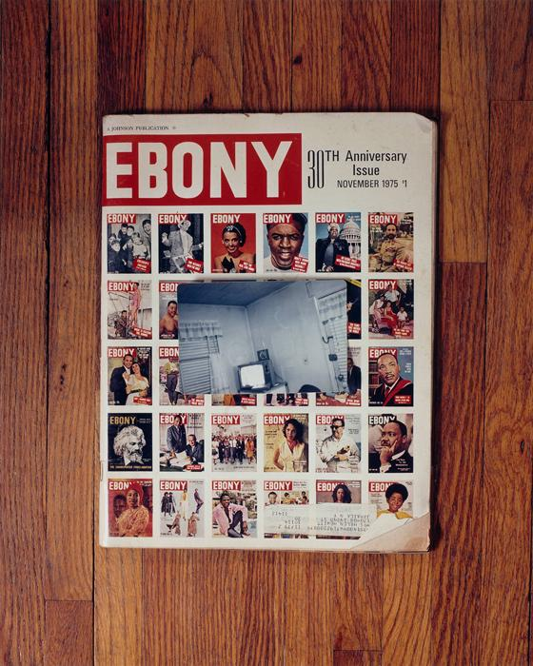
Leslie Hewitt. Riffs on Real Time. 2002–05. Chromogenic color print, 30 × 24" (76.2 × 61 cm). The Museum of Modern Art, New York. Fund for the Twenty-First Century. © 2020 Leslie Hewitt
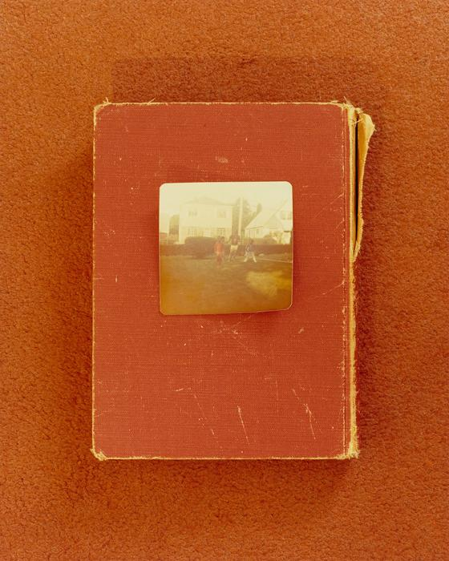
Leslie Hewitt. Riffs on Real Time. 2002–05. Chromogenic color print, 30 × 24" (76.2 × 61 cm). The Museum of Modern Art, New York. Fund for the Twenty-First Century. © 2020 Leslie Hewitt
For her series Riffs on Real Time, Hewitt repurposed domestic and personal objects such as family snapshots, books, magazines, and handwritten letters to create still lifes that intertwine personal and historical narratives. Each photograph pictures three elements: a personal snapshot, a piece of historical or recent ephemera, and a highly textured colored backdrop meant to evoke textures and colors from domestic environments from an unspecified, but instantly recognizable era.
The works are meticulously composed, revealing Hewitt’s sculptural approach to image making. The play of meaning between the items in her photographs is sometimes deeply personal and other times more broadly political, often questioning the nostalgia that is evoked through family mementos and relics of the civil rights era. In her own words, this process of layering and photographing allows Hewitt to “explore the limits of a single photograph, a single perspective.”
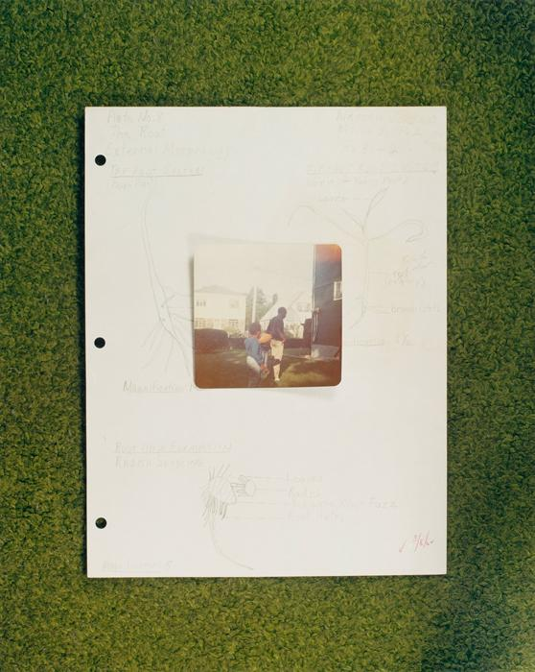
Leslie Hewitt. Riffs on Real Time. 2002–05. Chromogenic color print, 30 × 24" (76.2 × 61 cm). The Museum of Modern Art, New York. Fund for the Twenty-First Century. © 2020 Leslie Hewitt
Coming of age during a time where disposable cameras made photographs easier to produce, Riffs on Real Time reflects Hewitt’s fascination with the tangible nature of pictures. “A photograph, or at least an analog photograph, is always about the past,” she states. “It stops time momentarily and then we appreciate it (that moment) from the present tense looking back. I have always found this attribute of the photographic experience intriguing and important to how we perceive time.”

Aïda Muluneh
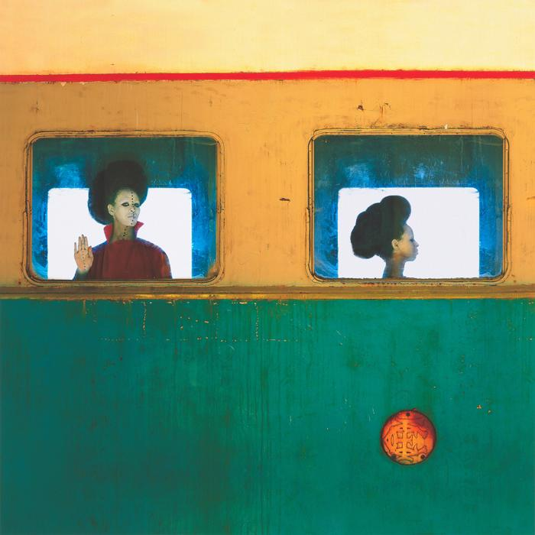
Aïda Muluneh. The Departure. 2016. Pigmented inkjet print, 31 1/2 × 31 1/2" (80 × 80 cm). The Museum of Modern Art, New York. Fund for the Twenty-First Century. © 2020 Aiïda Muluneh
Aïda Muluneh recognizes the capacity of photography to convey the multiplicity and contradictions inherent in any individual. Framed by the transparent square of what appears to be a bus window, the image shows two iterations of the same figure: one faces the camera and raises a hand in a gesture of salutation, while the other looks ahead.
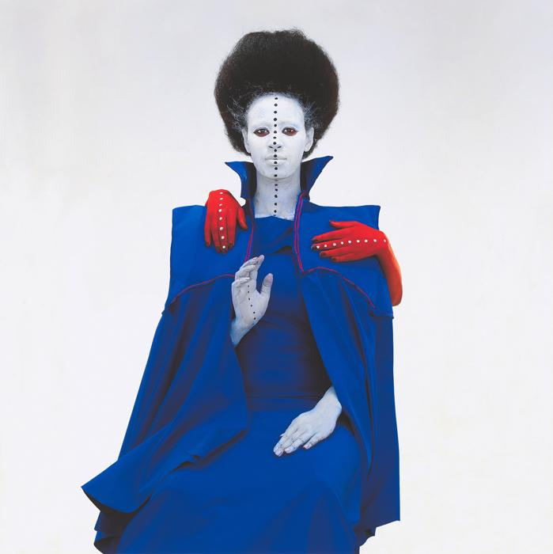
Aïda Muluneh. All in One. 2016. Pigmented inkjet print, 31 1/2 × 31 1/2" (80 × 80 cm). The Museum of Modern Art, New York. Fund for the Twenty-First Century. © 2020 Aiïda Muluneh
Here, a single figure similarly embodies multiplicity with an extra pair of hands in red. Muluneh’s use of colorful makeup is inspired by body art from across Africa and allows her to physically construct a character out of her model. Though she was born in Ethiopia, she has sometimes felt like an outsider due to many years spent elsewhere. These two photographs are from her series The World is 9, which is named after a saying by her grandmother: “The world is nine; it is never complete and it’s never perfect.”

Sohrab Hura
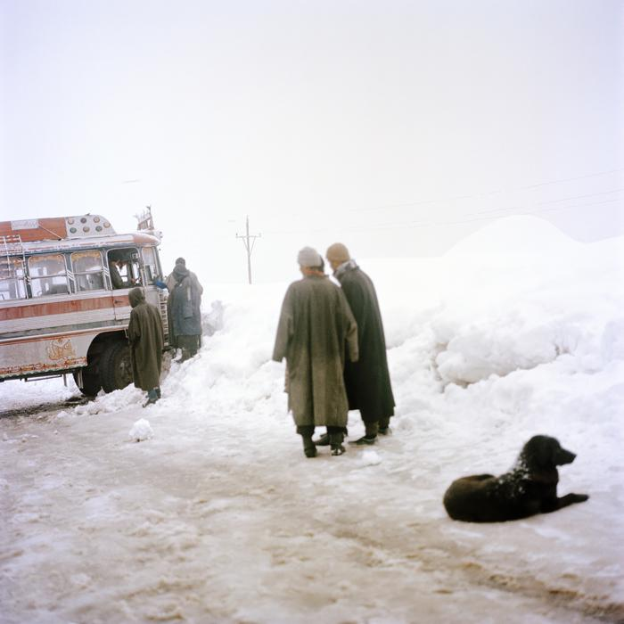
Sohrab Hura. Untitled from the series Snow. 2015–ongoing. Pigmented inkjet print, 24 x 24" (61 x 61 cm). Photo courtesy the artist and Experimenter, Kolkata. © 2020 Sohrab Hura
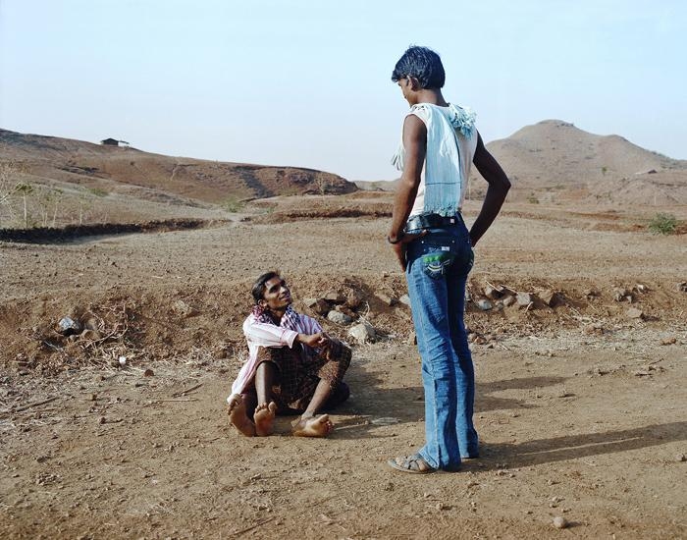
Sohrab Hura. Untitled from The Song of Sparrows in a Hundred Days of Summer. 2013–ongoing. Pigmented inkjet print, 5 1/2 x 7" (14 x 17.8 cm). Photo courtesy the artist and Experimenter, Kolkata. © 2020 Sohrab Hura
Sohrab Hura has expressed the hope that his work can be “experienced like a tree” with deep roots: each body of work is a separate branch, and “no matter how different from the neighboring ones,” each is “connected to the other branches by a single trunk.”
These works represent two multi-year series of photographs made in different regions: Snow, photographed over multiple winter seasons in Kashmir; and The Song of Sparrows in a Hundred Days of Summer, shot in the central Indian province of Madhya Pradesh. By pairing series that chronicle two extreme seasons, Hura emphasizes the distinctive characteristics of each. Beginning with the first flakes of winter, the photographs in Snow unfold to reveal not only the change in seasons, but also the violent reality of war and occupation that lies beneath the surface. In Sparrows, the stillness of time in the summer heat is palpable. Across both bodies of work, Hura aims to “learn and unlearn” the biased stories he has inherited by practicing close observation and listening.

